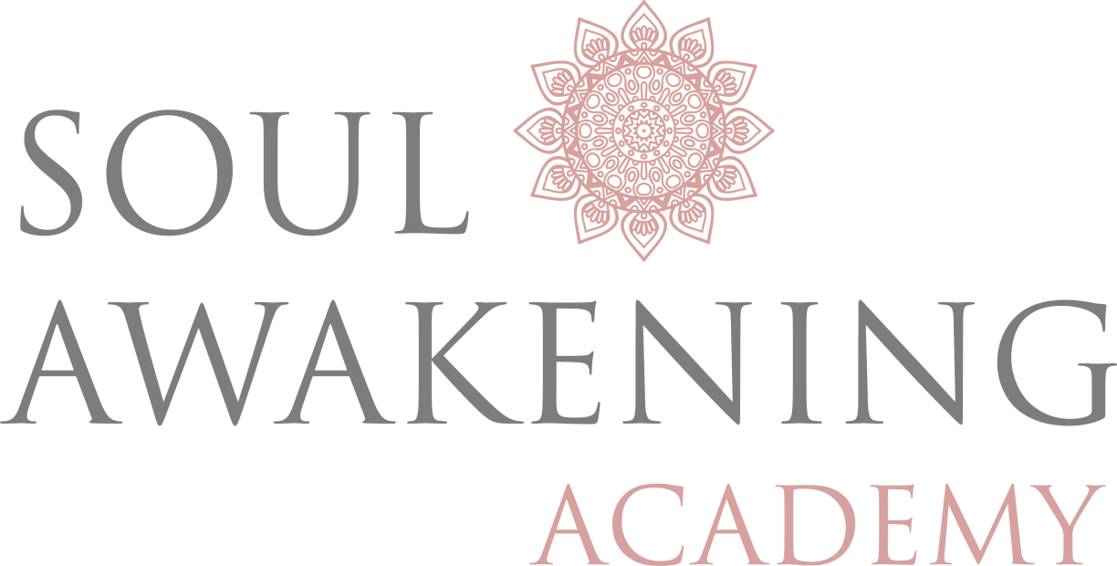

Soul Alignment

Breakthrough

Coaching

Module 1

**The R**oot

**Identity, roots, family, belonging, support, foundation, trust, stability and structure**



Our Root Chakra is located at the base of our spine. It’s the first of the 7 main chakras because energy flows upwards through us from the Earth before travelling on to the remaining 6.

Our Root chakra is our base of being. Our Tether to Earth, where all of our core, “Root” aspects come from. It influences our needs such as safety and security. It’s where we store our survival instincts and influences our feelings of abundance or scarcity.

It keeps us grounded, as it is our most physical chakra.

When it is damaged or blocked, it can cause feelings of anxiety, scarcity and fear. These feelings can cause negative manifestations in your life such as:

* Trust issues
* Money Problems
* Instability in Life, Jobs or Relationships
* Limiting beliefs that we take into adult life.

Physical ailments may appear in the lower body such as feet, legs, knee (etc) pain. It could also manifest as a lowered immune system or fertility problems.

Our Root Chakra becomes blocked or damaged by situations and circumstances in our lives that have made us feel unsafe, physically hurt or in a state of lack or danger in any way. Clearing and restoring proper energy flow will help you to find balance so that you may move onto the next chakra.

# Root Chakra Breakthrough Questions

## Your Current Reality:

#### 1. Right now, how do you feel in life? Do you feel stuck? Standing still? Sinking? Pressured, Free? Insecure? Unstable? Moving forward etc? Describe how you feel and why.

............................................................................................................................

............................................................................................................................

............................................................................................................................

............................................................................................................................

............................................................................................................................

............................................................................................................................

............................................................................................................................

............................................................................................................................

............................................................................................................................

............................................................................................................................

............................................................................................................................

...........................................................................................................................

............................................................................................................................

............................................................................................................................

#### 2. Ultimately what would you like to move towards? What would you like your life to look like in, 1year from now? 3 years from now? 5 years from now?

............................................................................................................................

............................................................................................................................

............................................................................................................................

............................................................................................................................

............................................................................................................................

............................................................................................................................

............................................................................................................................

............................................................................................................................

............................................................................................................................

............................................................................................................................

............................................................................................................................

...........................................................................................................................

............................................................................................................................

............................................................................................................................

............................................................................................................................

# Related imageYour Root Story:

#### Where do you feel lies your biggest insecurity, fear or blockage? Is it, your identity (place in the world)? Money? Health? Family? Lovability? Belonging? Expressing yourself fully? Relationships? Intimacy? Spirituality or other?

............................................................................................................................

............................................................................................................................

............................................................................................................................

............................................................................................................................

............................................................................................................................

............................................................................................................................

............................................................................................................................

............................................................................................................................

............................................................................................................................

............................................................................................................................

**If this fear, block or insecurity had roots, where would they go back to?**

**Where do you feel yourself holding back the most?**

**How would your life transform if you removed the blockage of fear or doubt?**

............................................................................................................................

............................................................................................................................

............................................................................................................................

............................................................................................................................

............................................................................................................................

............................................................................................................................

............................................................................................................................

............................................................................................................................

............................................................................................................................

............................................................................................................................

............................................................................................................................

...........................................................................................................................

............................................................................................................................

............................................................................................................................

............................................................................................................................

**If anything were possible what would be the next step forward?**

............................................................................................................................

............................................................................................................................

............................................................................................................................

............................................................................................................................

............................................................................................................................

............................................................................................................................

............................................................................................................................

............................................................................................................................

............................................................................................................................

............................................................................................................................

............................................................................................................................

...........................................................................................................................

............................................................................................................................

............................................................................................................................

............................................................................................................................

# Trust

**Tell me how Trust & Survival have played out in your life.**

Do you trust easily? If not, why not? Have you felt safe & supported throughout life or have you felt fearful, alone or abandoned?

............................................................................................................................

............................................................................................................................

............................................................................................................................

............................................................................................................................

............................................................................................................................

............................................................................................................................

............................................................................................................................

............................................................................................................................

............................................................................................................................

............................................................................................................................

............................................................................................................................

...........................................................................................................................

............................................................................................................................

............................................................................................................................

............................................................................................................................

**What or who lies at the root of this?**

............................................................................................................................

............................................................................................................................

............................................................................................................................

............................................................................................................................

............................................................................................................................

............................................................................................................................

............................................................................................................................

............................................................................................................................

............................................................................................................................

............................................................................................................................

............................................................................................................................

...........................................................................................................................

............................................................................................................................

............................................................................................................................

............................................................................................................................

# Change & Flexibility

**How do you feel taking risks in life/relationships/career/social situations?**

Have there been times in which you wished you had taken an opportunity but didn’t through fear of change? Or have you taken major risks and wished you hadn’t?

............................................................................................................................

............................................................................................................................

............................................................................................................................

............................................................................................................................

............................................................................................................................

............................................................................................................................

............................................................................................................................

............................................................................................................................

............................................................................................................................

............................................................................................................................

............................................................................................................................

...........................................................................................................................

............................................................................................................................

............................................................................................................................

............................................................................................................................

**How do you embrace change in your life? Would you consider yourself a risk taker or are you more risk adverse?**

Do you welcome it and embrace the change or do you push against it? What is at the root cause of this?

............................................................................................................................

............................................................................................................................

............................................................................................................................

............................................................................................................................

............................................................................................................................

............................................................................................................................

............................................................................................................................

............................................................................................................................

............................................................................................................................

............................................................................................................................

............................................................................................................................

...........................................................................................................................

............................................................................................................................

............................................................................................................................

............................................................................................................................

**Tell me about a situation in which you stayed too long because you feared changed?**

Or a time when you jumped ship too quickly because you needed change? What was at the root cause of this?

............................................................................................................................

............................................................................................................................

............................................................................................................................

............................................................................................................................

............................................................................................................................

............................................................................................................................

............................................................................................................................

............................................................................................................................

............................................................................................................................

............................................................................................................................

............................................................................................................................

...........................................................................................................................

............................................................................................................................

............................................................................................................................

............................................................................................................................

# Money Story

**What was your family’s relationship to money, work and taking risks?**

............................................................................................................................

............................................................................................................................

............................................................................................................................

............................................................................................................................

............................................................................................................................

............................................................................................................................

............................................................................................................................

............................................................................................................................

............................................................................................................................

............................................................................................................................

............................................................................................................................

...........................................................................................................................

............................................................................................................................

............................................................................................................................

............................................................................................................................

**What is your relationship like to money? I.e. what is your money pattern? Do you struggle to make ends meet? Live day to day? Or do you make money easily? Give it away? Gamble etc. please explain your relationship to money.**

............................................................................................................................

............................................................................................................................

............................................................................................................................

............................................................................................................................

............................................................................................................................

............................................................................................................................

............................................................................................................................

............................................................................................................................

............................................................................................................................

............................................................................................................................

............................................................................................................................

...........................................................................................................................

............................................................................................................................

............................................................................................................................

............................................................................................................................

# Career & Success

**What is your career story? Have you created the success and recognition you deserve? Or do you get overlooked and feel undervalued for the work you do? Please explain**

............................................................................................................................

............................................................................................................................

............................................................................................................................

............................................................................................................................

............................................................................................................................

............................................................................................................................

............................................................................................................................

............................................................................................................................

............................................................................................................................

............................................................................................................................

............................................................................................................................

...........................................................................................................................

............................................................................................................................

............................................................................................................................

............................................................................................................................

**Where, what or from whom might this pattern stem from?**

............................................................................................................................

............................................................................................................................

............................................................................................................................

............................................................................................................................

............................................................................................................................

............................................................................................................................

............................................................................................................................

............................................................................................................................

............................................................................................................................

............................................................................................................................

............................................................................................................................

...........................................................................................................................

............................................................................................................................

............................................................................................................................

............................................................................................................................

# Self-worth Script Activity

**Answer as honestly as possible, what do you feel you deserve in life? Not what you want but what you actually deserve? Now compare this to what you want.**

|  |  |  |
| --- | --- | --- |
| **What I want** | **What I feel deserve** | **The limiting belief is** |
| **To be financially independent** | **Not to make it in this world and I will always rely on others for financial security** | **I am not good enough** |
|  |  |  |
|  |  |  |
|  |  |  |
|  |  |  |
|  |  |  |
|  |  |  |

**What insights or AHA moments have you got from this exercise?**

............................................................................................................................

............................................................................................................................

............................................................................................................................

............................................................................................................................

............................................................................................................................

............................................................................................................................

............................................................................................................................

............................................................................................................................

............................................................................................................................

............................................................................................................................

............................................................................................................................

...........................................................................................................................

............................................................................................................................

............................................................................................................................

............................................................................................................................

# Limiting Belief Script

## Example

**Think back to your childhood. What were the main rules you have to follow in order to feel accepted?**

1. **The rules I had to follow were:**

For example, I always had to be quiet when out in public or when my parents had friends round.

1. **What would happen if you broke those rules?**

For example, I would be told I was a bad girl and that I demanded too much attention from people and I was needy. I was often sent to my room alone for hours on end.

1. **What did you believe about yourself for breaking these rules or adhering to these rules? What did you believe about those who didn’t?**

For example, If I followed the rules of being quiet then I was told I was a good girl, therefore I believed staying quiet made me a good girl. If I was a good girl and stayed quiet I could be in the company of others without being sent away. I believed if you spoke out you would be sent away and people who did speak out were show offs, rude or bad and that it is better to be quiet.

# Limiting Belief Script Activity

List all ways in which you carry out these rules today.

1. **The family rules I had to follow were:**

............................................................................................................................

............................................................................................................................

............................................................................................................................

............................................................................................................................

............................................................................................................................

............................................................................................................................

............................................................................................................................

............................................................................................................................

............................................................................................................................

............................................................................................................................

............................................................................................................................

...........................................................................................................................

............................................................................................................................

............................................................................................................................

............................................................................................................................

1. **Using the rules you had to follow list, what would happen if you or someone else broke these family rules? What messages did you receive about yourself or others who were rule breakers?**

............................................................................................................................

............................................................................................................................

............................................................................................................................

............................................................................................................................

............................................................................................................................

............................................................................................................................

............................................................................................................................

............................................................................................................................

............................................................................................................................

............................................................................................................................

............................................................................................................................

...........................................................................................................................

............................................................................................................................

............................................................................................................................

............................................................................................................................

**3. By following these rules what positive messages, statements, rewards or beliefs did you receive about yourself?**

............................................................................................................................

............................................................................................................................

............................................................................................................................

............................................................................................................................

............................................................................................................................

............................................................................................................................

............................................................................................................................

............................................................................................................................

............................................................................................................................

............................................................................................................................

............................................................................................................................

...........................................................................................................................

............................................................................................................................

............................................................................................................................

............................................................................................................................

|  |  |  |  |  |
| --- | --- | --- | --- | --- |
| Old Rule/Belief | Holds me back because | Makes me feel | I want to feel | New positive Rule/Belief |
| *I have to be quiet and not be heard.* | *I always get overlooked at work.* | *Unappreciated and undervalued.* | *Valued.* | *I give myself permission to voice my opinions and express my ideas.* |
|  |  |  |  |  |
|  |  |  |  |  |
|  |  |  |  |  |
|  |  |  |  |  |
|  |  |  |  |  |
|  |  |  |  |  |

**Using your limiting beliefs from the previous exercise, how do you feel these rules or beliefs might be holding you back today? And what new positive rules or positive belief statements can you decide to live by to help going forward? Use the table below to fill out your answers.**

# Positive Affirmations & Daily Mantra

**What new positive rules or positive belief statements are you going to install to help you live your best life? You’re your top 3.**

Old Beliefs/Rule New Beliefs/Rules

☐ I have to be strong all of the time ☐ I give myself permission to ask others for help

☐ ☐

☐ ☐

☐ ☐

#### Now take the positive belief statement that resonates with you the most and turn this into a daily mantra or affirmation. Tell me why you choose this one and what this affirmation or mantra mean to you.

............................................................................................................................

............................................................................................................................

............................................................................................................................

............................................................................................................................

............................................................................................................................

............................................................................................................................

............................................................................................................................

............................................................................................................................

............................................................................................................................

............................................................................................................................

............................................................................................................................

...........................................................................................................................

............................................................................................................................

............................................................................................................................

............................................................................................................................

# Learning to Let Go Exercise

**Before we can learn to let go of our past, we must clearly identify the things that are holding us back. Only then can we learn to heal ourselves. The following exercise is designed to help identify the things blocking our progress and our healing.**

To get what I want I must let go of ............................................. (called ‘x’):

............................................................................................................................

............................................................................................................................

............................................................................................................................

............................................................................................................................

............................................................................................................................

............................................................................................................................

............................................................................................................................

............................................................................................................................

............................................................................................................................

............................................................................................................................

There is a part of me that does not want to give up ‘x’ because:

............................................................................................................................

............................................................................................................................

............................................................................................................................

............................................................................................................................

............................................................................................................................

............................................................................................................................

............................................................................................................................

............................................................................................................................

............................................................................................................................

............................................................................................................................

............................................................................................................................

...........................................................................................................................

............................................................................................................................

............................................................................................................................

............................................................................................................................

The benefit of not letting go of ‘X’ is/are:

............................................................................................................................

............................................................................................................................

............................................................................................................................

............................................................................................................................

............................................................................................................................

However, benefit of letting go of ‘X’ is:

............................................................................................................................

............................................................................................................................

............................................................................................................................

............................................................................................................................

............................................................................................................................

............................................................................................................................

............................................................................................................................

............................................................................................................................

............................................................................................................................

............................................................................................................................

............................................................................................................................

...........................................................................................................................

............................................................................................................................

............................................................................................................................

............................................................................................................................

If anything were possible I would:

............................................................................................................................

............................................................................................................................

............................................................................................................................

............................................................................................................................

To make that happen, I need to:

............................................................................................................................

............................................................................................................................

............................................................................................................................

............................................................................................................................

............................................................................................................................

............................................................................................................................

............................................................................................................................

............................................................................................................................

............................................................................................................................

............................................................................................................................

............................................................................................................................

...........................................................................................................................

............................................................................................................................

............................................................................................................................

............................................................................................................................

What I need to let go of the most is:

............................................................................................................................

............................................................................................................................

............................................................................................................................

............................................................................................................................

What needs to really change is:

............................................................................................................................

............................................................................................................................

............................................................................................................................

............................................................................................................................

............................................................................................................................

............................................................................................................................

............................................................................................................................

............................................................................................................................

............................................................................................................................

............................................................................................................................

............................................................................................................................

...........................................................................................................................

............................................................................................................................

............................................................................................................................

............................................................................................................................

What small step can you action straight away to implement the change?

............................................................................................................................

............................................................................................................................

............................................................................................................................

............................................................................................................................

............................................................................................................................

............................................................................................................................

............................................................................................................................

............................................................................................................................

............................................................................................................................

............................................................................................................................

............................................................................................................................

...........................................................................................................................

............................................................................................................................

............................................................................................................................

............................................................................................................................

Positive Affirmations: Choose the one that resonates with you the most. You are invited to say this affirmation out loud every day as often as possible until our next session.

1. Change is natural and easy for me, as I trust in myself to make the right decisions.
2. I am willing to leave my old ways behind and embrace a new way of thinking and living.
3. It is safe for me to let go of who I am now and transform into the person I want to be.
4. As I make the changes within my reality starts to reflect that back to me in positive, inspiring ways.
5. As life is ever changing, I flow with the changes embracing the new.
6. Change is freedom of the old and makes way for the mew.
7. I trust my instincts in everything I do and with everyone I meet.

# Take Home:

**What have been the biggest insights or AHA moments from this exercise?**

............................................................................................................................

............................................................................................................................

............................................................................................................................

............................................................................................................................

............................................................................................................................

............................................................................................................................

............................................................................................................................

............................................................................................................................

............................................................................................................................

............................................................................................................................

............................................................................................................................

...........................................................................................................................

............................................................................................................................

............................................................................................................................

............................................................................................................................

**What do you feel like doing/changing/auctioning as a direct result?**

............................................................................................................................

............................................................................................................................

............................................................................................................................

............................................................................................................................

............................................................................................................................

............................................................................................................................

............................................................................................................................

............................................................................................................................

............................................................................................................................

............................................................................................................................

............................................................................................................................

...........................................................................................................................

............................................................................................................................

............................................................................................................................

**What small step can you take straight away to implement the change?**

............................................................................................................................

............................................................................................................................

............................................................................................................................

............................................................................................................................

............................................................................................................................

............................................................................................................................

............................................................................................................................

............................................................................................................................

............................................................................................................................

............................................................................................................................

............................................................................................................................

...........................................................................................................................

............................................................................................................................

............................................................................................................................

............................................................................................................................

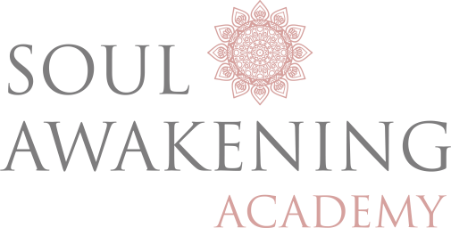

Notes…

Notes…

Notes…