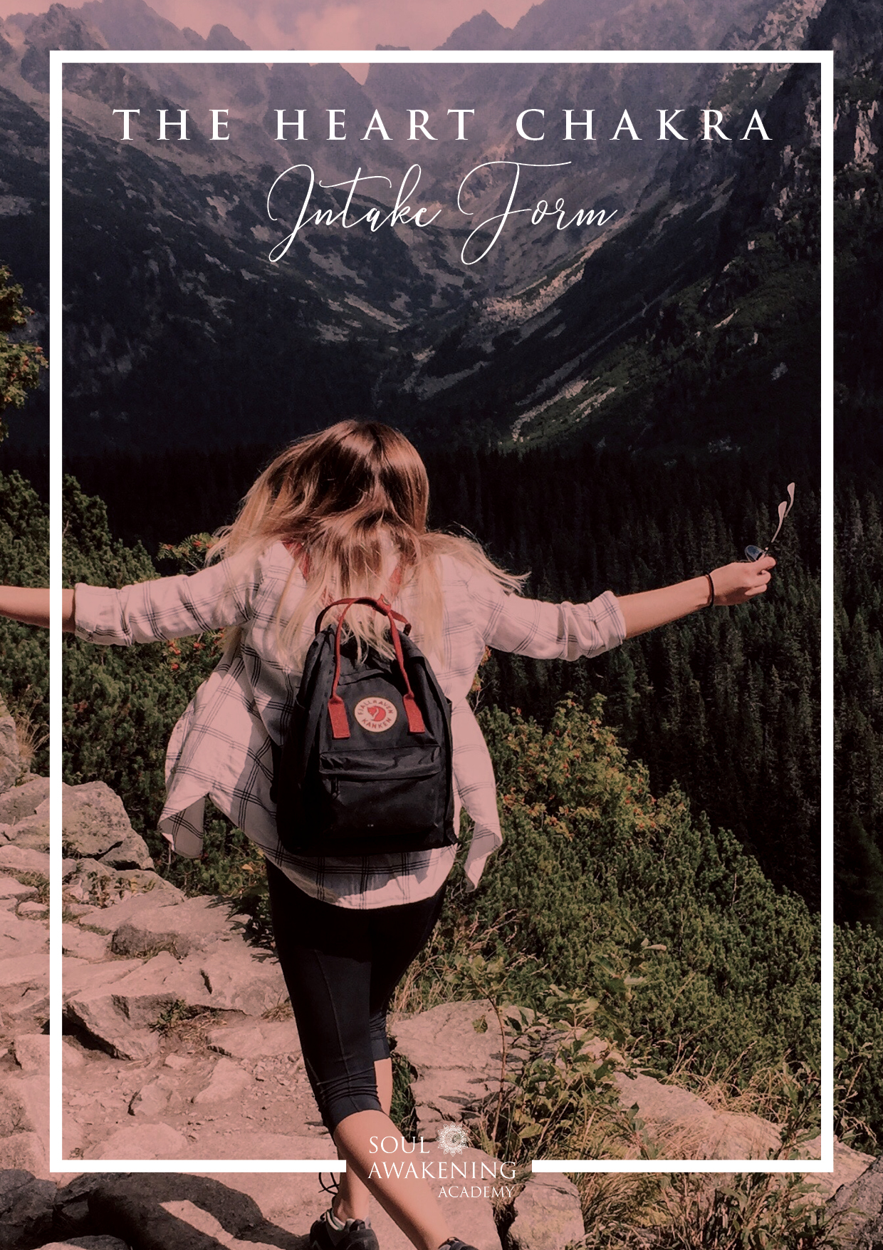

**Heart Chakra Story**

The Heart Chakra represents love, heart-break, compassion, self-love and the ability to give & receive love equally.

When it comes to matters of the heart, love, relationships, self-love & compassion. How has this played out for you in your life? Are you able to give and receive love equally? Do you know when you give yourself adequate care & self-love? Or do you shy away from love through fear of getting hurt? Tell me about this area of your life.

______________________________________________________________________________________________________________________________________________________________________________________________________________________________________________________________________________________________________________________________________________________________________________________________________________________________________________________________________________________________________________________________________________________________________________________________________________________________________________________________________________________________________________________________________________________________________________________________________________________________________________________________________________________________________________________________________________________________________________________________________________________________________________________________________________________________________________________________________________________________________________________________________________________________________________________________________________________________________________________________________________________________________________________________________________________________________________________________________________________________________________________________________________________________________________________________________________________________________________________________________________________________________________________________________________________________________________**__________________________________________________________________________________________________________________________________________________________________________________________________________________________________________________________________________________________________________________________________________________________________________________________________________________________________________________________________________________________________________________________________________________________________________________________**__________________________________________________________________________________________________________________________________________________________________________________________________________________________________________________________________________________________________________________________________________________________________________________________________________________________________________________________________________________________________________________________________________________________________________________________

**Life Balance**

**Represents the centre of love and gratitude. When this chakra is open and flowing only love, compassion and gratitude can reside. You will be quick to forgive and you will be able to accept yourself and others easily without judgment or conditions.**

**Imbalances in this chakra can present themselves with emotions such as jealousy, anger, grief, harsh judgements and criticisms. You may harbour feelings of being unloved or unable to fully love because of fear of rejection. There may be a need to hurt others when hurt as a form of protection, retaliation or defence. Relationships can prove to be difficult if this chakra is out of balance.**

**Some signs when this is out of balance: Do you feel consumed by your emotions? Are you unable to forgive yourself and others? Do you overly give to others but find it hard to receive?**

**Life Balance: Describe your general life balance. In terms of love, giving & receiving, nurture etc. Do you feel your life is harmonious or imbalanced and why?**

**Yes, very balanced because……………….......................................................................................................**

**Not at all balanced because…………………...................................................................................................**

**Sometimes balanced because…………........................................................................................................**

**What are your main sources of imbalances when it comes to matters of the heart? And have you noticed a pattern of any kind? _____________________________________________________________________________________________________________________________________________________________________________________________________________________________________________________________________________________________**

**Which of the following most describes you?**

**☐ I do more for others than I do myself.**

**☐ I often give more that I get back.**

**☐ I do more for myself than I do for others.**

**☐ I feel loved.**

**☐ I lack love.**

**☐ I accept love easily.**

**☐ I accept compliments easily.**

**☐ I give compliments easily**

**Wheel of Life & Goals**

**Rate the level of your emotional wellbeing in each area:**

**The centre of the wheel is zero and the outer edge is 10. For each aspect of your life place an X to represent your current level of satisfaction in each life domain.**

**Note: You can rename any of the life areas that suit you the most.**

**Inner Peace /10 Self Love /10 Physical Health /10 Happiness /10 Quality of Life /10**

**Relationships /10 Spirituality /10 Personal Growth /10**

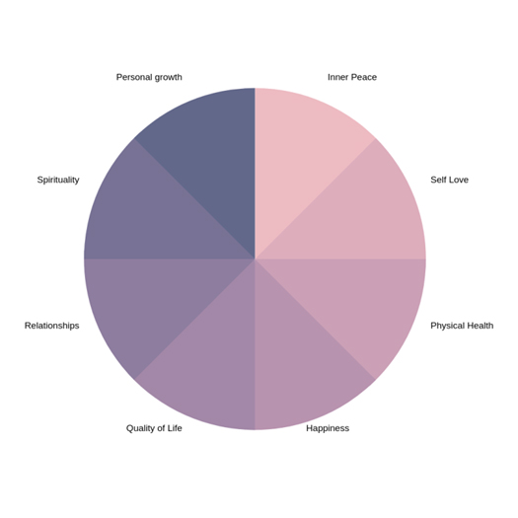

**Life Balance Worksheet**

**Based on your results, which area would you most like to improve and why? ____________________**

**What do you want to create/ experience more of in this area of your life? ____________________**

**Why do you want this? ____________________**

**Who will you become as you improve this area of your life? ___________________**

**What stops you having this? What have you been holding on to that no longer serves you?**

**What belief? ____________________**

**What self-talk? ____________________**

**What fear? ____________________**

**Growth**

**How do you personally want to grow in this area of your life?**

**One way I want to grow emotionally is: ____________________**

**One way I want to grow mentally is: ____________________**

**One way I want to grow spiritually is: ____________________**

**One way I want to grow physically is: ____________________**

**How does this future growth make you feel?**